**Visual Learning in the Digital Age:** *Why Students Prefer YouTube Over Textbooks*

**Submitted by:** Dakareddy Abhinav Reddy

**Internship Track:** Research & Insight Development

**Assignment Option:** Option 1 – Behavioral or Tech Adoption Insight Report

**Date:**24 June 2025

**Submitted to:** Jayadhi Limited (UK & India)  
 Research Assistant Internship – Entry Level

**INTRODUCTION**

In the past decade, student learning habits have undergone a major transformation. Traditional methods—such as relying solely on textbooks and classroom lectures—are increasingly being supplemented or replaced by digital platforms. Among these, YouTube has emerged as a leading learning tool, offering students quick, visual, and easily accessible explanations across a wide range of subjects.

Understanding why students prefer YouTube over textbooks is essential for educators, EdTech innovators, and policymakers. Analyzing this trend offers valuable insights into modern learning behaviors, and can inform the design of more effective educational tools, blended learning models, and content strategies tailored for the digital generation.

**KEY INSIGHTS AND PATTERN**

**1.Visual, Multi‑modal Format Enhances Retention**Educational videos combining visual, auditory, and textual elements lead to better memory retention—about +2 marks on average, and up to +7 when replacing textbooks

***Citation-*** *Mayer, R. E. (2009). Multimedia Learning (2nd ed.). Cambridge University Press.*

**2.On‑Demand, Personalized Learning**

Around 64% of students value learning at their own pace through videos, and

54% prefer recorded formats similar to YouTube over live instruction

***Citation-*** *uQualio. (2025, May 28). Video Learning is Essential: Student Preferences 2024. uQualio.*

**3.YouTube as Gen Z’s Preferred Learning Tool**

Nearly 60–68% of Gen Z students aged 14–23 favor YouTube over textbooks for

learning. They seek quick, purposeful learning

***citation****:uQualio. (2025, May 28). Video Learning is Essential: Student Preferences 2024. uQualio****.***

**4.Supplementing Where Textbooks Fall Short**

In India, 84% of students in a university survey preferred video-based content

supplemented by reading, while only 0.65% opted for reading-only formats

***citation:****Muthu Prasad, T., Aiswarya, S., Aditya, K., & Jha, G. K. (2021).*

*Students Perception and preference for online education in India during COVID-19*

*pandemic. Social Sciences & Humanities Open, 3(1), 100101.*

**Target Audience Behavior Breakdown**

### **Who is Affected?**

**Primary Group:** Students aged **13 to 24** (Gen Z)

**Level of Education:** High school to undergraduate level

**Location:** Predominantly urban and semi-urban India, but growing in rural areas due to smartphone and internet penetration

**Device Access:** Mostly use smartphones, followed by tablets and laptops

**STATS AND VISUAL SUGGESTION**

### **Pie Chart: Learning Format Preference**

* Video + reading: 84.4%
* Live-only: 17.9%
* Reading-only: 0.65%

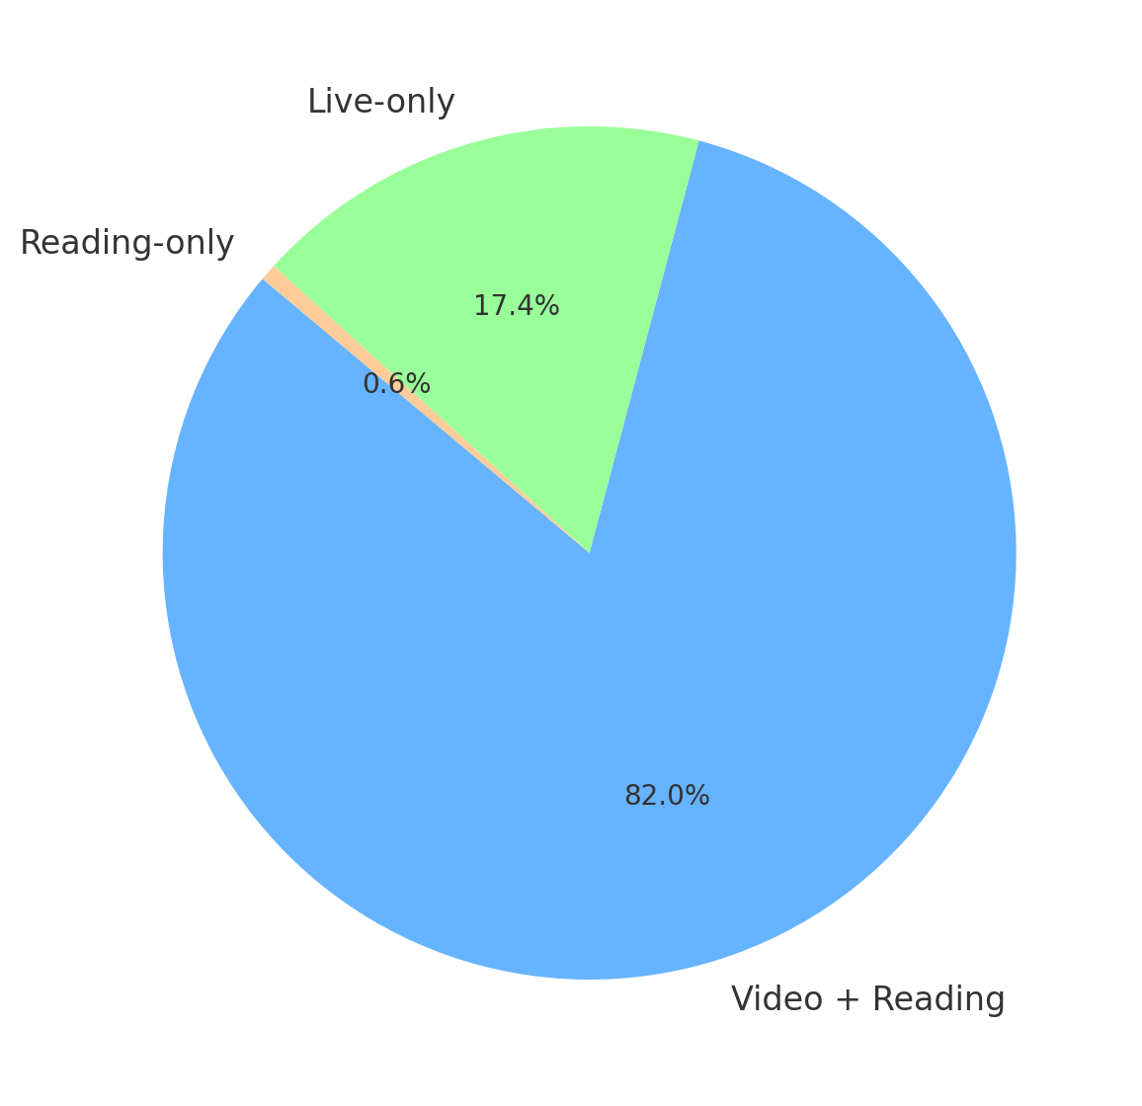

**Learning Format Preference**

Illustrates that a majority of students (84.4%) prefer a mix of video and reading-based learning, compared to minimal preference for text-only formats (0.65%).

### **Bar Graph: Gen Z Format Usage**

* Prefer YouTube: ~60%
* Prefer Textbooks: ~47%

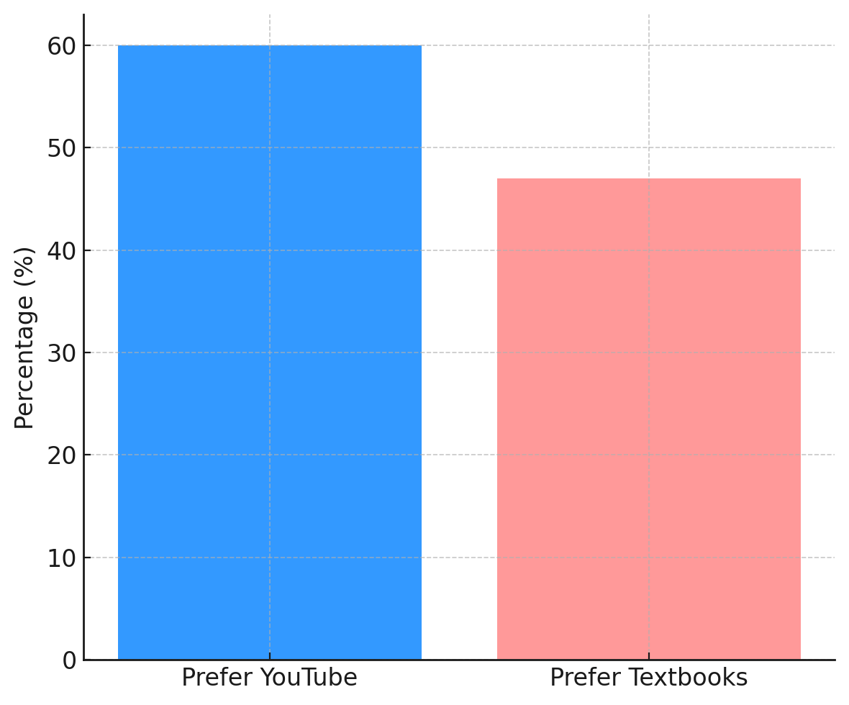

**Gen Z Format Usage**

Highlights that ~60% of Gen Z learners prefer YouTube as their primary learning tool, compared to 47% who rely on textbooks.

**Implications for Product Teams or Educators**

### The shift toward visual platforms like YouTube offers valuable direction for EdTech and education stakeholders:

* EdTech Teams should develop AI-powered tools that recommend personalized video content based on a student’s level and pace. Adding interactive quizzes and vernacular options can improve engagement.
* Educators can adopt blended models, using curated videos to supplement textbooks and enable flipped classrooms.
* Curriculum Designers should include short, modular video content alongside reading material to match Gen Z’s learning style.